Rotary Club of Kathmandu Mid-Town
Breakfast Chatter



15 September 2006 The Weekly Bulletin of Rotary Club of Kathmandu Mid-Town Bc # 11 of 2006-07

District : 3290 Web: www.rotarymidtown.org.np Club Id : 26776

SEPTEMBER IS NEW GENERATIONS MONTH
Interact serves as a natural lead-in to Rotaract, a service club for students ages 18-30. Rotaract clubs are able to take on more ambitious projects and work more independently. In addition to their service agenda, Rotaract clubs also focus on professional development, public speaking, and career development. Rotaractors are a connecting bridge to Rotary because they understand Rotary values and often help participate in joint projects.

Newly Inducted Rotarian Pratap Malla talking to the Club members;
Actg President Subarna Joshi looks on.
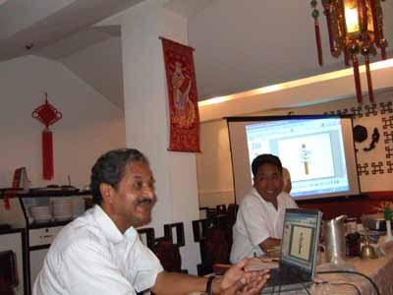
Rtn Pratap provided an insight into what goes in the making of UN Peace Keeping Mission in reference to MINURSO, the mission where he served for over 6 years, on Friday morning, 8th September.

Weekly Meetings and Programs
Date | Program/Speaker | Program/Topics of Presentation
15 Sept 2006 | Jhalak Anand | Importance of Yoga and Pranayama
22 September 2006 | Club Assembly | Progress review club activities

Friday, 15 September morning :
Yoga Instructor Jhalak Bista Anand will be providing an insight into Yoga and will be teaching club members Pranayama (breathing exercise). Hatha Yoga includes Aasana (Posture), Pranayama (Breathing Control), Concentration and Meditation, Shuddhi Kriya (Yogic Cleansing of the Physical Body). According to WHO research about 80% people don’t know how to breathe correctly. People are utilizing only one-third capacity of their lungs; this is why they are suffering from various psychosomatic problems.

Congratulations and Welcome :
Three new members were inducted to the Club on 27 August at the ICM on Membership Development and Retention and they were provided Rotary Pin by DG Debasish Mitra on a special program : Rtn Pratap Malla, Rtn Dr Isabella C Bassignana Khadka and Rtn Manish K Bhansali. Congratulations to you all for becoming Rotarian and coming into the Rotary International family. A warm welcome to you all !

Mid-Towners ! Are you there in this photograph ? 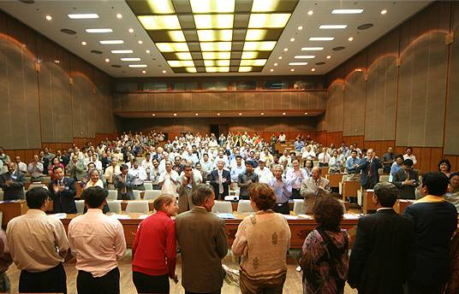
You are for sure ! Altogether 26 Mid-Towners were present in the ICM
held on Sunday evening, 27 August 2006 at Nuptse Hall of BICC, Baneswor.
Over 200 Rotarians from 43 Rotary Clubs both from the Valley and outside participated in the program that discussed various issues in Membership Development and Retention.
Altogether seven Rotarians were inducted on the occasion : 3 to Kathmandu Mid-Town,
3 to Kathmandu Metro and 1 to Patan South.
Photo Courtsy : Rtn Navyo Eller

Orientation for New Members :
Proper member education should begin well before the induction ceremony. Educating potential members about the basics of Rotary club membership provides them with realistic expectations about the benefits and obligations of membership.
Many clubs make special presentations to new members to inform them of the structure and history of Rotary, RI and district activities, as well as the club’s activities. These presentations provide an orientation for new and prospective members and their spouses and can feature current or past club leaders discussing various aspects of Rotary.

In a Restaurant :
Diner : I can't eat such a rotten chicken. Call your manager !
Waiter : It's no use. He won't eat it either !

Recognizing the real needs of others is an essential part of being a Rotarian. That is why I emphasize to you the importance of listening, listening to the people you wish to help and identifying their real needs. This is how we can do the very most with what we have.
RI President William B. Boyd

15 September 2006 The Weekly Bulletin of Rotary Club of Kathmandu Mid-Town Bc # 11 of 2006-07

Editor: RR Shrestha, Club Service Director email: rryes@wlink.com.np

